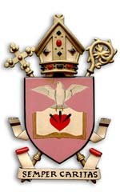

Sacraments of Initiation

Information for Families

|  |  |  |  |  |
| --- | --- | --- | --- | --- |
| **SACRAMENT** | **DATE** | **TIME** | **WHO SHOULD ATTEND** | **WHAT SHOULD MY CHILD WEAR** |
| Reconciliation  (First Confession) | March:  Thursday 27/03/24 | 6pm | Family (including Godparents) – pew per family | Formal school uniform |
| Confirmation | June:  Tuesday 03/06/24 | 6pm | Family (including Godparents) – pew per family | Formal school uniform |
| First Holy Communion | June:  Saturday 07/06/24 | 11am | Family (including Godparents) – pew per family | Girls – white dress  Boys – formal wear or formal school uniform |

Communicants are welcome to attend Mass on Sunday 8th June in their communion attire.