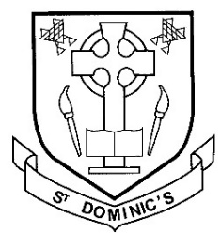Version 1

Clubs @ St Dominic’s RC Primary School & ELC

|  |  |
| --- | --- |
|  | |
| Monday | Lunchtime Chess club for P1-P4 Pupils 12:40 – 1pm |
| Tuesday | **P5 & P6** Lunchtime Homework club @ 1 – 1:20pm |
| **P5 -P7** Richmond House Singing Group with Mrs Brogan @ 3pm |
| Wednesday | Lunchtime Rosary club with Mrs Dowell @ 12pm |
| **P7** Homework club 3:30 – 4pm |
| **P5-P7 (And Pupil Council Reps & Rights Respecting Steering Groups from P1-P4)** – three weekly meetings: 28th August, 18th September, 23rd October,  13th November, 4th December, 8th & 29th January, 19th February, 12th March  2nd April, 7th & 28th May, 18th June. |
| Thursday |  |
| Friday | **ELC** Rhyme Time in nursery @ 9:10 -9:40am |
|  | |

n.b.